

Land Information Ontario (LIO) Warehouse

Data Class Name: Transport Point

Documentation

Produced by: Information Access and Information Management Policy Unit

Ministry of Natural Resources and Forestry

Date: July 27, 2015

**Purpose**

This document provides additional information to support the use of geospatial data. The Physical Model Diagram provides a visual representation of the relationships in the data class. The Data Change History lists all the modelling and access changes that have occurred during the lifecycle of the data class. A data description identifying table and field names is available upon request.

**Need Assistance?**

Please contact LIO Support at [lio@ontario.ca](mailto:lio@ontario.ca) or 705-755-1878 if you require help.

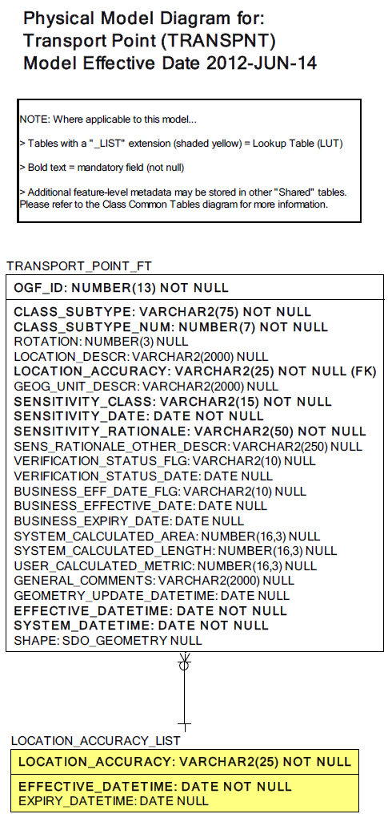  
Data Class Change History

Data Class Name: Transport Point

Data Class Short Name: TRANSPNT

| Date  YYYY-MM-DD | Details of Change |
| --- | --- |
| **2014** | Retired – no longer maintained or supported |
| **2008** | New data class description updated at Base Data Infrastructure's request. |
| **2002** | Converted to structured Data Class with the addition of the following tables:  - GEOG_UNIT  - JUSTIFICATION  - EXTERNAL_REFERENCE  - TRANSPORT_POINT (New Feature Class Table) |
| **1997** | NEW basic Data Class to house former Ontario Base Map (OBM) point features. |

**Data Description**  
Please refer to the metadata record for the data description.